**Software Design And Architecture**

**Assignment : 2**

**Name : Mian Habib Jan**

**Reg No: SP21-BSE-042**

**Semester Project: Attendance Management System**

**Chapter : 1 (Use Case Diagram)**

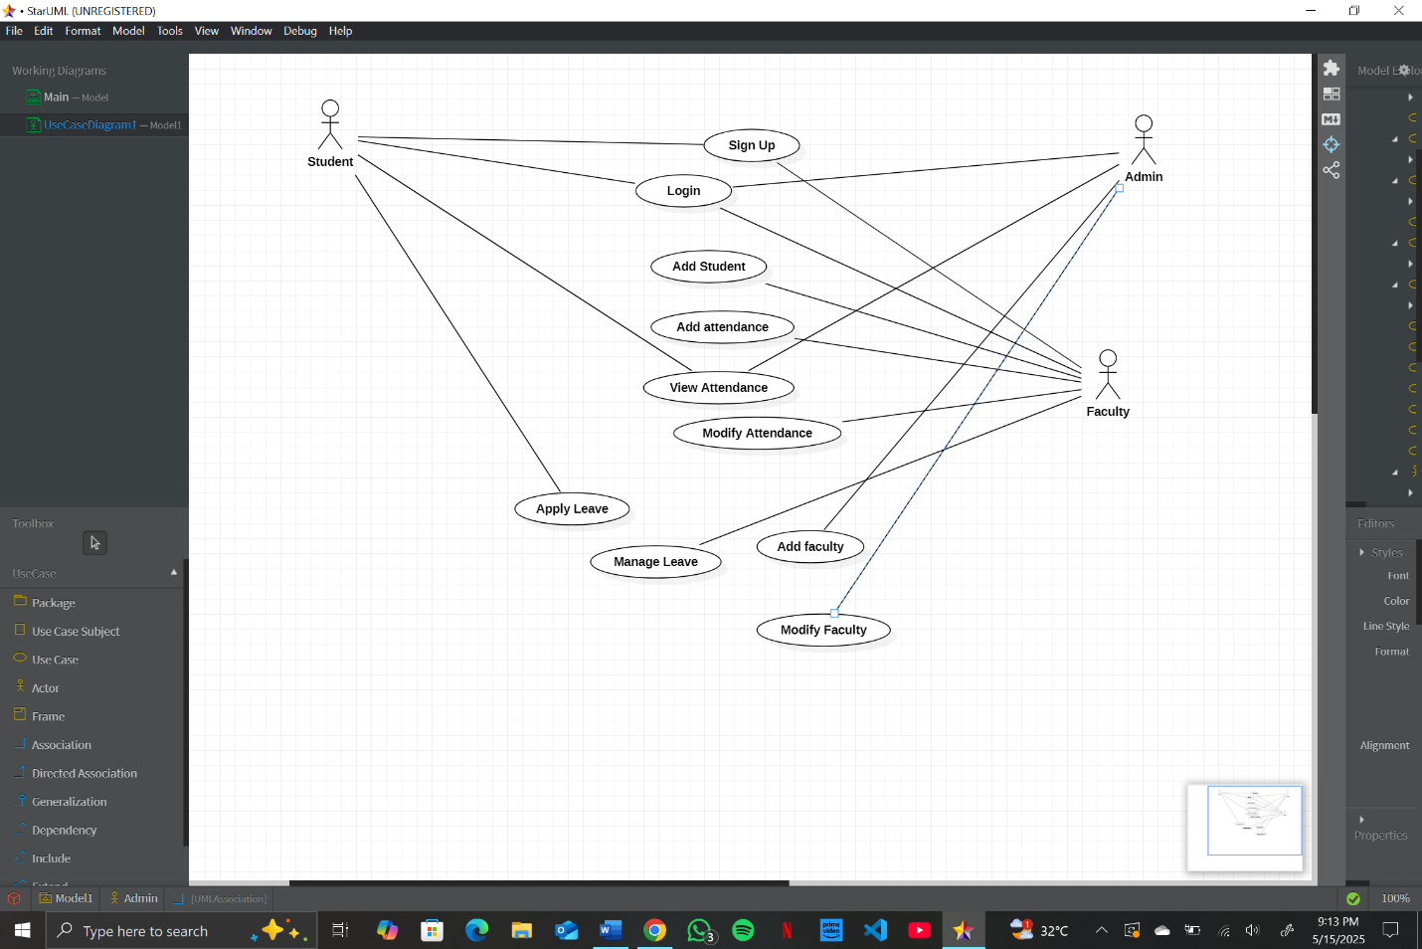

**Chapter : 2 (Fully Dressed Use Cases)**

**Use Case 1: Sign Up**

**Primary Actor**: Student, Faculty, Admin.  
**Goal in Context**: To allow new users to register in the system.  
**Preconditions**: The user does not already have an account.  
**Trigger**: The user navigates to the sign-up page.  
**Main Success Scenario**:

1. The user provides personal details (e.g., name, email, role).
2. The system validates the input.
3. The system creates a new user account and notifies the user of successful registration.

**Extensions**:

* If the email already exists, the system prompts an error message.  
  **Postconditions**: The user is successfully registered and can log in.

**Use Case 2: Login**

**Primary Actor**: Student, Faculty, Admin.  
**Goal in Context**: To authenticate and grant access to the system.  
**Preconditions**: The user must have a valid account.  
**Trigger**: The user submits login credentials.  
**Main Success Scenario**:

1. The user enters their username and password.
2. The system verifies credentials.
3. The user is granted access to their respective dashboard.

**Extensions**:

* If the credentials are invalid, the system displays an error message.  
  **Postconditions**: The user is logged in.

**Use Case 3: Add Student**

**Primary Actor**: Admin  
**Goal in Context**: To add a new student to the system.  
**Preconditions**: The student is not already in the system.  
**Trigger**: The admin navigates to the "Add Student" page.  
**Main Success Scenario**:

1. The admin enters the students’ details.
2. The system validates information.
3. The student is added to the database.

**Extensions**:

* If details are invalid, the system notifies the admin.  
  **Postconditions**: The student is successfully added.

**Use Case 4: Add Attendance**

**Primary Actor**: Faculty, Admin  
**Goal in Context**: To record attendance for a class or group.  
**Preconditions**: The class or group must already exist.  
**Trigger**: The user navigates to the "Add Attendance" feature.  
**Main Success Scenario**:

1. The user selects the class/group and the date.
2. The user marks attendance for individuals.
3. The system saves the attendance record.

**Extensions**:

* If the class does not exist, the system prompts an error.  
  **Postconditions**: Attendance is successfully recorded.

**Use Case 5: View Attendance**

**Primary Actor**: Student, Faculty, Admin  
**Goal in Context**: To view attendance records.  
**Preconditions**: The system must have attendance data.  
**Trigger**: The user requests to view attendance.  
**Main Success Scenario**:

1. The user selects the desired filters (e.g., date range, class).
2. The system displays the attendance records.

**Extensions**:

* If no records are found, the system notifies the user.  
  **Postconditions**: The user successfully views attendance.

**Use Case 6: Modify Attendance**

**Primary Actor**: Faculty, Admin  
**Goal in Context**: To edit an existing attendance record.  
**Preconditions**: There must be an existing attendance record to modify.  
**Trigger**: The user navigates to the "Modify Attendance" feature.  
**Main Success Scenario**:

1. The user selects the record to edit.
2. The user makes the necessary changes.
3. The system updates the attendance record.

**Extensions**:

If the record does not exist, the system notifies the user.  
**Postconditions**: Attendance record is updated.

**Use Case 7: Apply Leave**

**Primary Actor**: Student  
**Goal in Context**: To allow a student to request leave.  
**Preconditions**: The user must be logged in.  
**Trigger**: The user selects the "Apply Leave" option.  
**Main Success Scenario**:

1. The user fills out a leave request form with relevant details.
2. The system sends the request to the faculty or admin for approval.

**Extensions**:

* If required details are missing, the system prompts an error.  
  **Postconditions**: Leave request is submitted successfully.

**Use Case 8: Manage Leave**

**Primary Actor**: Faculty, Admin  
**Goal in Context**: To review and approve/reject leave requests.  
**Preconditions**: There must be leave requests in the system.  
**Trigger**: The user navigates to the "Manage Leave" page.  
**Main Success Scenario**:

1. The user views pending leave requests.
2. The user approves or rejects a request.
3. The system updates the leave status.

**Extensions**:

* If no requests are pending, the system notifies the user.  
  **Postconditions**: Leave request is processed.

**Use Case 9: Add Faculty**

**Primary Actor**: Admin  
**Goal in Context**: To add a new faculty member to the system.  
**Preconditions**: The faculty member must not already exist in the system.  
**Trigger**: The admin navigates to the "Add Faculty" page.  
**Main Success Scenario**:

1. The admin enters the faculty details.
2. The system validates the data.
3. The faculty member is added to the system.

**Extensions**:

* If details are invalid, the system prompts an error.  
  **Postconditions**: Faculty member is successfully added.

**Use Case 10: Modify Faculty**

**Primary Actor**: Admin  
**Goal in Context**: To update faculty details in the system.  
**Preconditions**: The faculty member must already exist in the system.  
**Trigger**: The admin selects the "Modify Faculty" option.  
**Main Success Scenario**:

1. The admin selects the faculty record to edit.
2. The admin updates the necessary details.
3. The system saves the changes.

**Extensions**:

* If the faculty record does not exist, the system notifies the admin.  
  **Postconditions**: Faculty details are updated.

**Chapter : 3 (SSD’s)**

**Use Case 1: Sign Up**

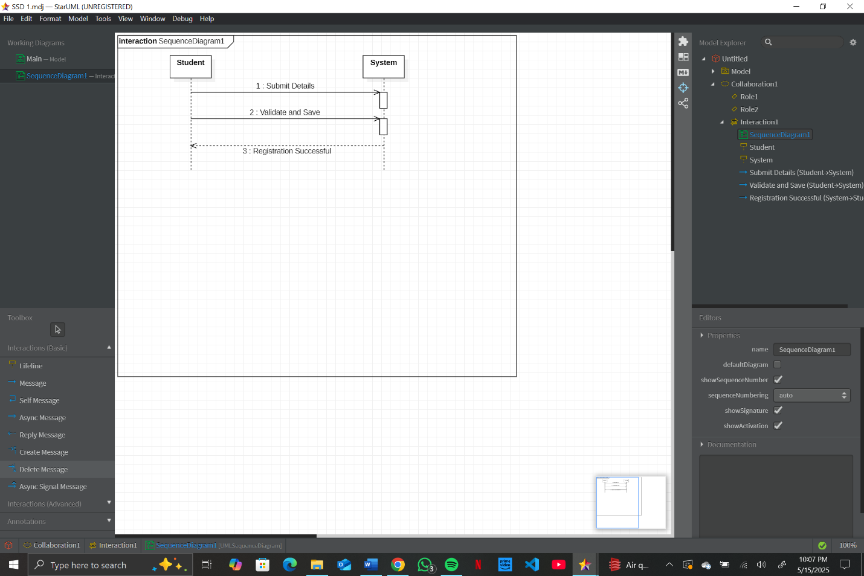

**Use Case 2: Login**

**Use Case 3: Add Student**

**Use Case 4: Add Attendance**

**Use Case 5: View Attendance**

**Use Case 6: Modify Attendance**

**Use Case 7: Apply Leave**

**Use Case 8: Manage Leave**

**Use Case 9: Add Faculty**

**Use Case 10: Modify Faculty**

**Chapter : 4 (Package Diagram)**

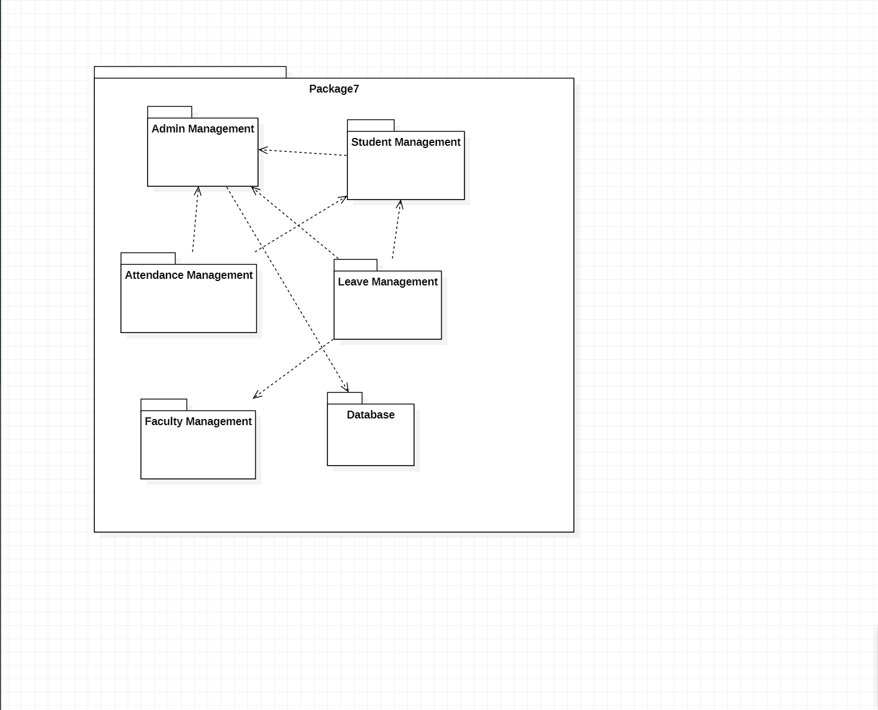

**Chapter: 5 (Sequence Diagram)**

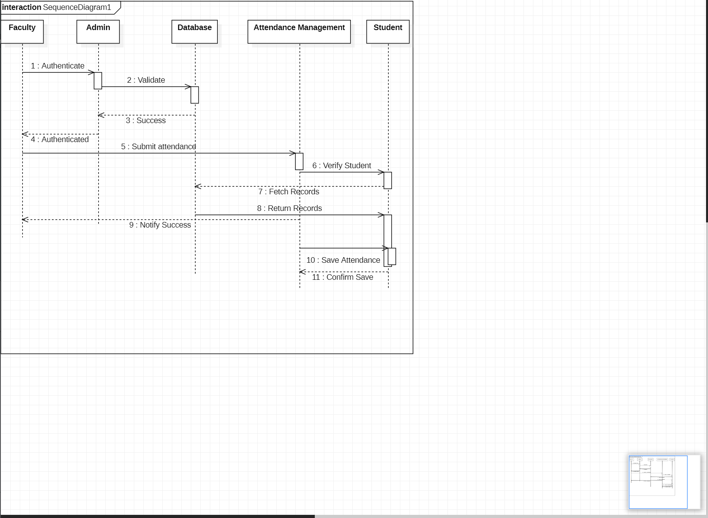

**Chapter: 6 (Class Diagram)**

